**FSI Membership Application**

**Form to undersign by aspirant members of the Floriculture Sustainability Initiative**

***This first page outlines the application process for potential members and the guidelines for acceptance of membership.***

**1. Application**

An organization that applies for FSI membership submits the following at the FSI Secretariat:

* 1. Completed application form, including initialed membership rules and fees.
  2. Description of the organization, incl. mission statement, goals, relationship to the floriculture sector (max. 1 page)
  3. Motivation to join FSI.

1. **Admission**
2. The FSI Secretariat presents the application to the FSI Board. The Board may ask for additional information about the applicant.
3. The Board will vote whether or not to approve membership.
4. The FSI Board can reject a membership application if the applicant has neither demonstrated a perceptible commitment to a sustainable floriculture sector nor a valid stakeholder interest in the objectives of FSI, or if any social, environmental or legal grievances are found.
5. **Membership**
   * 1. The FSI secretariat will inform the applicant of their acceptance or rejection within two months of having received the application.
     2. The FSI secretariat also calculates the membership fee for each applicant according to the membership rules.
     3. Only when the membership fee is received, the applicant is considered a member, and the organization can communicate about their FSI membership.
     4. Approved applicants will be added to the FSI members’ directory on the FSI website.
     5. Members will be sent the FSI logo for display on their website once payment has been received.

*Page 1 FSI Membership Application - 2023*

**Application Form**

**Parties making the application to become member of FSI:**

|  |  |  |  |  |  |  |
| --- | --- | --- | --- | --- | --- | --- |
| **PART 1 – General information** | | | | | |  |
| **Organization name:** | Click or tap here to enter text. | | | | |  |
| **Type of organization:** |  | | | | |  |
| Individual company/organization | | | | |  |
|  | Sector organization national | |  | | |  |
|  | Sector organization international | | | | |  |
|  | Foundation | | | | |  |
| **Contact person:** | Click or tap here to enter text. | |  | | |  |
|  |  | |  | | |  |
| **Position:** | Click or tap here to enter text. | **Official Address:** | |  | Click or tap here to enter text. |
| **Email:** |  | **Postal code:** | |  |  |
| Click or tap here to enter text. |  | Click or tap here to enter text. |
| **Telephone:** |  | **Country:** | |  |  |
| Click or tap here to enter text. |  | Click or tap here to enter text. |
|  |  |  | |  |  |
| **Website:** |  |  | |  |  |
| Click or tap here to enter text. |  |  |
|  |  |  | |  |  |

***Hereby applies to become members of FSI:***

There are two kinds of memberships at FSI:

**Ordinary members** are companies directly involved in the supply chain; and associations, organizations, foundations, federations, or confederations active in the floriculture sector, falling into one of the following stakeholder groups. Ordinary members have voting rights at the General Assembly.

|  |  |  |  |
| --- | --- | --- | --- |
| **Stakeholder group:** | Producer North | Trade/Wholesale |  |
|  | Producer (Sub-) Tropical | Standard/Certification Scheme |  |
|  | Retail | Civil Society Organization |  |

**Associate membership** is open and accessible to all other stakeholders and Industry members in the floriculture sector who do not meet the criteria to be eligible as Ordinary member. Associate members do not have voting rights.

|  |  |  |  |
| --- | --- | --- | --- |
|  | Other, please specify: Click or tap here to enter text. |  |  |

*Page 2 FSI Membership Application – 2023*

***Membership fees***

As a member of FSI, one of your contributions will be an annual membership fee that will be invoiced at the beginning of each calendar year. FSI membership fees are charged according to the category, size or annual turnover of your organization:

|  |  |  |
| --- | --- | --- |
| **Membership category** | **Size (if applicable)** | **Fee (EUR)** |
| **Sector organizations** | < 25 companies and revenue < EUR 150,000 | **2,250.00** |
| > 25 companies or revenue > EUR 150.000 | **5,250.00** |
| **Retail/florists** | < 20 stores | **750.00** |
| > 20 stores or online sales | **4,500.00** |
| **Trade/Wholesale/Industry** | revenue < EUR 2.5 mio | **2,250.00** |
| revenue EUR 2.5 mio – 50 mio | **3,000.00** |
| revenue > EUR 50 mio | **4,500.00** |
| **Producers** | revenue < EUR 1 mio | **750.00** |
| revenue EUR 1 mio – 8 mio | **2,250.00** |
| revenue > EUR 8 million | **4,500.00** |
| **CSOs** |  | **2,250.00** |
| **Standards/Certification Schemes** |  | **2,250.00** |
| **All others/ Associate members** |  | **1,500.00** |

***Membership Rules***

1. **Membership categories**
   1. FSI membership is open to profit and not-for-profit organizations that are a stakeholder in the international floricultural sector.
   2. Each Member organization shall appoint one or more natural persons to represent it within FSI. One person shall be identified as key contact for all correspondence with FSI.
2. **Rights of FSI members**
   1. Ordinary members are entitled to vote in the General Assembly meetings. They can be elected for a seat in the Board and can be invited by the FSI Board to participate in one or more Working Groups.
   2. Associate and industry members are observing members and can be invited by the FSI Board to participate in one of the Working groups
   3. All members are encouraged to take part in the General Assembly meetings and engage in the discussion with FSI throughout the year.
   4. All FSI members will be informed about the activities of FSI and its members through the FSI secretariat.

*Page 3 FSI Membership Application – 2023*

1. **Duties of FSI members:**

**- For all FSI members:**

* 1. They commit to the vision, mission and ambitions of FSI and actively work towards the 2025 objectives in terms of financial and personal contribution.
  2. They commit, adopt, integrate, use and adhere to the FSI Code of Conduct for floriculture.
  3. They actively share information and interact within their supply chain and network, to increase their and the industry’s achievements towards FSI objectives.
  4. They pay their membership fee (section 4 & appendix I) in time.
  5. They represent their respective organization and become ambassadors of FSI.
  6. They promote and communicate their commitment throughout their own organization and to their customers, suppliers, subcontractors and other relevant actors of the supply chain from production to consumption.

**- For FSI members producing, trading and/or retailing flowers and plants:**

* 1. They report to the FSI secretariat on their volumes of responsible flowers and plants, and actions taken to reach 90% responsible production and/or trade. They are responsible for their own verification through an internal/external accountant.
  2. They report on their status/progress regarding the Responsible Conduct topics: Footprint and Living Wages.
  3. They agree with the internal rules as set out in the FSI 2025 monitoring protocol and provide a yearly Action Plan with their production/procurement objectives to FSI for review, guidance and support.

1. **Membership fees**
   1. FSI members shall pay an annual membership fee.
   2. The FSI Board reviews the amount, scaling method of membership fees on an annual basis and submits the proposal to the General Assembly for approval.
   3. Membership fees must be paid at the latest 30 days after they receive the invoice.
   4. Members joining FSI part way through a financial year shall pay the amount of membership fees as calculated for their membership category on a pro rata basis.
2. **Termination of membership and readmission**
   1. Membership terminates by:
   2. Voluntary withdrawal. Possible any time via written notice of resignation to the FSI secretariat. No reimbursement of membership fee.
   3. Exclusion from FSI based on a complaint (see separate complaint and grievance procedure) by the FSI Board. No reimbursement of membership fee.
   4. Failing to pay the membership fee in time.
   5. Dissolution of the member organization.
   6. Re-entry into FSI is possible if the respective reasons for termination of the membership are no longer valid. Readmission is possible at the discretion of the FSI Board without having to complete the application procedure for new members.

*Page 4 FSI Membership Application – 2023*

**Motivation for application**

## FSI AMBITION

FSI members endorse the overall FSI ambition a “Transparent and Responsible supply chain” in 2025. Under the three pillars of Responsible Production& Trade, Responsible Conduct and Integrated Reporting, FSI members commit to reach four objectives by 2025:

1. 90% responsibly produced and traded volumes ambition broadened to include new environmental and social aspects;
2. A reduction of the carbon footprint for selected products by 2025;
3. A Reduction of the living wage gap of workers at farm level by 2025;
4. 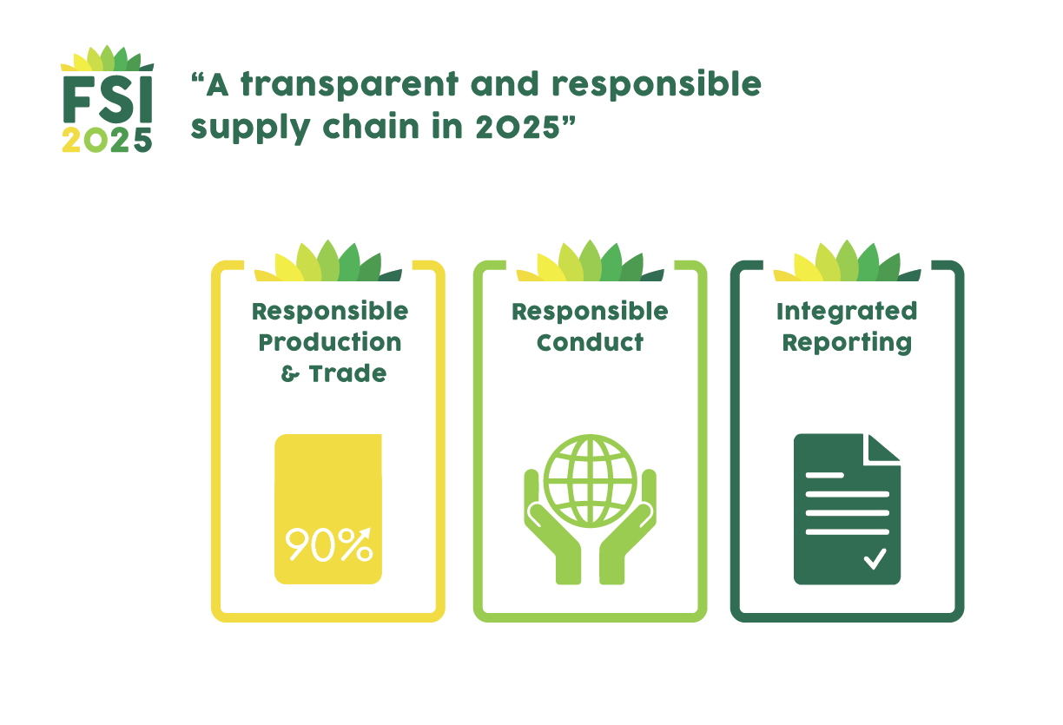Reporting on progress and integrate due diligence reporting by 2025.

|  |
| --- |
| **Describe what you can bring to the FSI ambition and objectives** |
| Click or tap here to enter text. |

|  |
| --- |
| **Describe what are your expectations as FSI member and how you will benefit from your membership** |
| Click or tap here to enter text. |

Members trading and/or retailing flowers and plants are expected to have started measuring their sustainable volumes within the first 6 months of their membership. Based on the outcome, they prepare an action plan to reach the 90% target and to make sustainable improvements at company and sector level, including communication and sharing of information within their supply chain.

*Page 5 FSI Membership Application – 2023*

## 2025 OBJECTIVES:

FSI members can engage in one or several working groups to contribute to the further planning and realization of FSI 2025 objectives. Please indicate which working group you would be interested join, if any:

|  |  |
| --- | --- |
| **Responsible production & Trade** | **Environmental Footprint** |
| **Living Wage** | **Integrated Reporting** |

## PROJECTS

FSI members are encouraged to speed up transformation and develop best practices through projects and business cases. Please explain how your organization could contribute and if applicable, describe the **project(s)** you would like to conduct and the organizations you would partner with?

|  |
| --- |
| **Describe your sustainability project idea(s) & potential partnerships** |
| Click or tap here to enter text. |

Please indicate which sustainability theme(s) your organization is keen to focus on:

**Social Environmental**

|  |  |  |  |
| --- | --- | --- | --- |
|  | **Gender** |  | **Environmental Footprint** |
|  | **Living Wage** |  | **IPM** |
|  | **Gender equality** |  | **Packaging/ Plastics** |

Please indicate if there are the **specific region(s)** you are focusing or would like to act on:

|  |  |
| --- | --- |
| **REGION** | **TOPIC** |
| Click or tap here to enter text. | Click or tap here to enter text. |
| Click or tap here to enter text. | Click or tap here to enter text. |
| Click or tap here to enter text. | Click or tap here to enter text. |

*Page 6 FSI Membership Application – 2023*

**SIGNATURE PAGE**

***In applying for FSI membership, our organization agrees to abide by the Articles of Associations as published on the FSI website and commit to the ambitions and objectives of FSI, including compliance with the FSI Basket of Standards and reporting of sustainable volumes if applicable.***

*By signing the application form I confirm that I have read and understood the Application Procedure and the FSI Membership Rules.*

|  |  |
| --- | --- |
| ***For*** *(your organization):* | Click or tap here to enter text. |
| ***Name:*** | Click or tap here to enter text. |
| ***Date:*** | Click or tap here to enter text. |
| ***Signature:*** |  |

*Page 7 FSI Membership Application – 2023*